SQL: Rolling Sum of Total Sales

-- DDL & DML

create table sales_rg (trx_date date, total_trx integer);
insert into sales_rg values ('2017-01-01', 200);
insert into sales_rg values ('2017-01-02', 100);
insert into sales_rg values ('2017-01-03', 100);
insert into sales_rg values ('2017-01-04', 200);
insert into sales_rg values ('2017-01-05', 300);
insert into sales_rg values ('2017-01-06', 400);
insert into sales_rg values ('2017-02-01', 200);
insert into sales_rg values ('2017-02-02', 400);
insert into sales_rg values ('2017-02-03', 600);
insert into sales_rg values ('2017-02-04', 500);
insert into sales_rg values ('2017-02-05', 200);
insert into sales_rg values ('2017-02-06', 600);
insert into sales_rg values ('2018-01-01', 400);
insert into sales_rg values ('2018-01-02', 300);
insert into sales_rg values ('2018-01-03', 500);
insert into sales_rg values ('2018-01-04', 600);
insert into sales_rg values ('2018-01-05', 500);
insert into sales_rg values ('2018-01-06', 700);
insert into sales_rg values ('2018-02-01', 800);
insert into sales_rg values ('2018-02-02', 300);
insert into sales_rg values ('2018-02-03', 200);
insert into sales_rg values ('2018-02-04', 500);
insert into sales_rg values ('2018-02-05', 600);
insert into sales_rg values ('2018-02-06', 500);

-- SQL: Rolling Sum of Total Sales
SELECT
trx_date, sales_value, sum(sales_value) over (partition by month(trx_date) order by trx_date) as running_sales_value
from sales_rg

- Let’s say if the data queried frequently, what improvements would you do?
The query output should be stored in table. For many case, we can do simple cronjob to schedule query then store data in table. But in this case, where everyone can query, we can build data mart, the aggregated layer in data warehouse. So everyone can use that pre-aggregated table, as many as they want, with small computation & small price.
Another improvements, can be helped by using BI tools such as Tableau, Power BI, etc. We can build certain dashboard contains this aggregated data in a single table. Also it’s better to build chart to make it easier to analyse.

SQL : Compare Monthly Sales in Different Year

-- SQL : Compare Monthly Sales in Different Year
with
sales_2017 as (
select monthname(trx_date) as bln, sum(sales_value) as sls
from sales_rg
where year(trx_date) = '2017'
group by bln
)
,
sales_2018 as (
select monthname(trx_date) as bln, sum(sales_value) as sls
from sales_rg
where year(trx_date) = '2018'
group by bln
)

select
s17.bln, s17.sls sales_2017, s18.sls sales_2018
from sales_2017 s17 inner join sales_2018 s18 on (s17.bln = s18.bln)

Coding : Match with One Asterisk
#!/usr/bin/python

def listToString(s):
str1 = ''
return (str1.join(s))

def stringMatching(string1, string2):

# print('list : ' + string2)
# print(lstring2.index('*'))
checklist = list('')
index = None

for i in range(0,255):
# print('i : ' + str(i) + ' char : ' + str(chr(i)))
lstring2 = list(string2)

try:
lstring2[lstring2.index('*')] = str(chr(i)).lower()
checklist = ''.join(lstring2)
# print('Now finding ' + listToString(checklist) + ' in ' + string1)

except ValueError:
print("List does not contain value")

if string1.find(listToString(checklist)) != -1:
indexnya = string1.find(listToString(checklist))
# print('found at index :', str(string1.find(listToString(checklist))))
break
else:
indexnya = -1
pass
# print(lstring2)
# print('ini :' + listToString(lstring2))

return indexnya

def main():
print(stringMatching('habibi','a*i'))

if __name__ == "__main__":
main()

Modeling: Online Book Store
- What are metrics we should look at?
- Reach :
Numbers of real users that registered in our online book store, including followers & users from email subscription. It is good to have consistent campaign to encourage our reach. It helps us increase reach if we defined better brand.
- Engagement
It defines how many users logged on, how many searched the products, how many finished transaction.
- Retention
Total numbers of old users who transact again. It can be considered as total users who’s loyal to our store.

- How the dimensional data model should be? What data we can explore? You can assume as creative as you can, on what data you would have on your dimensional data model

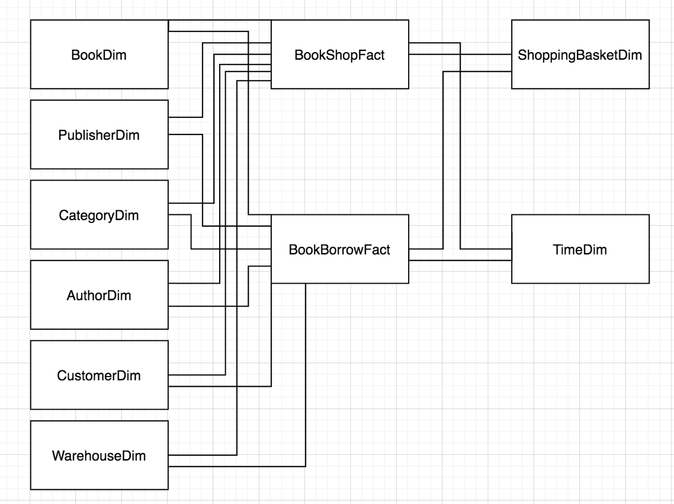

We have online book store that sell or borrow book. Some common dimensions designed in this data model, such as BookDim, PublisherDim, etc. Also including some fact table such as BookShopFact & BookBorrowFact.

- How should we design the ETL? What are the considerations?
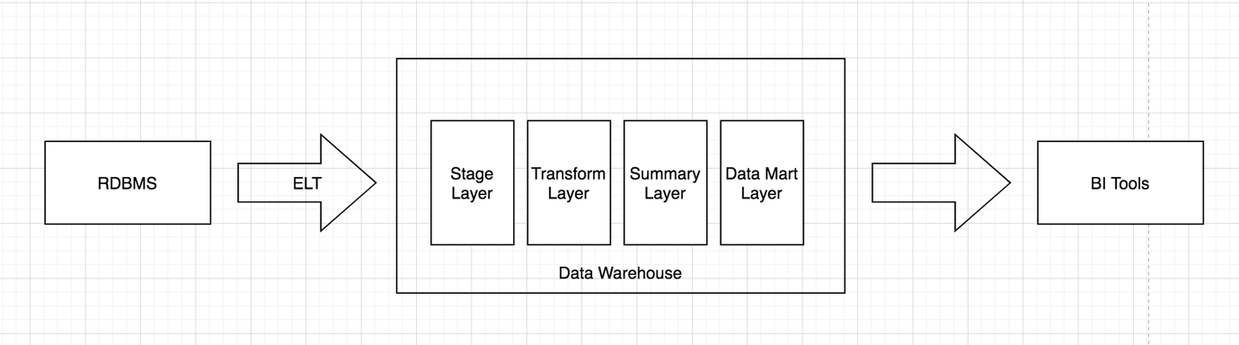
Above is ELT high level design architecture. I prefer use ELT concept/ big data tech stack to store and transform it, rather than ETL concept. I will let big data/cloud handle data transformation, including but not limited to data cleansing, data quality & data auditing.
There are 4 layers in data warehouse that we can consider. Stage Layer acts as AS-IS layer, store same data as online database store. Transform is the layer where all business logic should be applied there. Summary Layer is the aggregated form of the second layer. Then data mart layer acts as the aggregated layer that provides data for BI tools. The different between summary layer and data mart layer is the approach, where the former approaches to subject area and the latter approaches to several business unit/ certain department in company.

Considerations when we design data warehouse are :
- ETL/ ELT
- Data Source/ RDBMS
- Usage & Latency
- Data Loading : Incremental / Full Scale
- Data Expiration
- Data Quality
- Data Cleansing
- Data Transformation

